

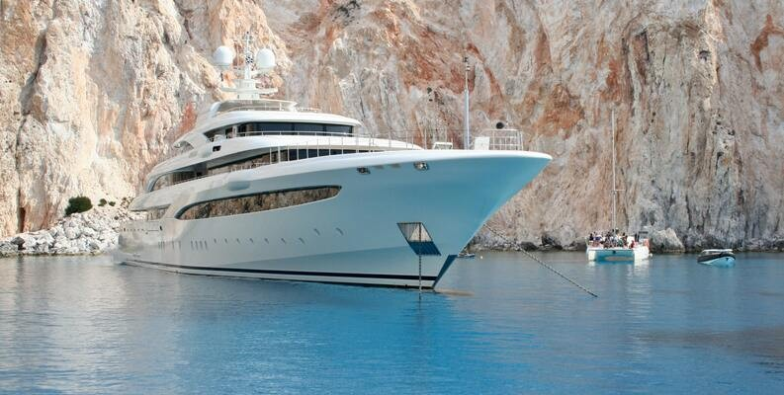

Boat Sales

21.12.2022

Halina Kryvanos

Data Analytics

**─**

**Executive Summary**

This dataset represents the sales information of used boats listed on a website. The website allows users to advertise their used boat for sales. This allows prospective buyers to have a ﬁrst impression about the boat, its manufacturing details, present conditions as well as listing price. The marketing has requested for the sales analysis in preparation of a weekly newsletter. Essentially, this analysis would help sellers by giving them insights on how they could get more engagement for listed

boats, as well as stay on top of the market trends.

# Data Sources

The data for this project is an open source data downloaded from [https://www.kaggle.com/datasets/karthikbhandary2/boat-sales](http://www.kaggle.com/datasets/karthikbhandary2/boat-sales)

# Limitation and Ethics

* The prices of the boats were listed in diﬀerent currency. This makes it diﬃcult to compare the price amongst the listed boats
* The location of the boats includes the country and an imprecise location which is not consistent across all the listings

# Data Cleaning and Data Consistency Checks

* Adjust the data type
* Convert the prices to a single currency
* Extract the country and city from the location
* Check for missing data
* Check for duplicate data
* Check for mixed data type

# Data Proﬁle

* Number of rows and columns in the cleaned dataset: 6001 x 11 (original data is, 9888 x 10)

# Column Details

|  |  |  |  |
| --- | --- | --- | --- |
| **Column** | **Column description** | **Data type** | **Time Variant** |
|  |  |  |  |
| Price | Boat prices listed in diﬀerent currency | Quantitative, Continuous | no |
| Boat Type | The type of listed boat | Qualitative, Ordinal | no |
| Manufacturer | The maker of the boat | Qualitative, Nominal | no |
| Type | The condition of the boat and engine type | Qualitative, Ordinal | no |
| Year | The year the boat was built | Quantitative, Discrete | no |
| Length | The length of the boat (in meter) | Quantitative, Continuous | no |
| Width | The width of the boat (in meter) | Quantitative, Continuous | no |
| Material | The material used to build the boat. | Qualitative, Nominal | no |
| Location | The present location of the listed boat | Qualitative, Nominal | no |
| Number of views last 7 days | The number of prospective customers that viewed the boat in the last 7 days. | Quantitative, Continuous | yes |

**Ǫuestions to Explore**

* Characteristics of the most viewed boat listing in the last 7 days
* What is the price of boat that get the most views?
* Are there common features among the most viewed boats?
* What is the location of the most viewed boat?